Assignment Module : 8 : - Network Access Basic routing and Advance routing concept, switching concept
Multiple Choice
1 . 4-R1, R2, R3, and R4 have their Fast Ethernet 0/0 interfaces attached to the same VLAN. A network engineer has typed a configuration for each router by using a word processor. He will later copy and paste the configuration into the routers. Examine the following exhibit, which lists configuration for the four routers, as typed by the network engineer. Assuming that all four routers can ping each other’s LAN IP addresses after the configuration has been applied, choose the routers that will be able to form a neighbor relationship with the other routers on the LAN. (You can assume that, if not shown in the exhibit, all other related parameters are still set to their defaults.) (Choose two)
A. R1
B. R2
C. R3
D. R4
E. None of the routers will exchange routing information.
Answer : ( A ) R1 and ( B ) R2
2 . 3-enable secret [password] is hashed using the algorithm.
A. MD5
B. AH
C. PSK
D. ESP
E. WPA2
Answer : ( A ) MD5
4- An engineer connects to Router R1 and issues a show ip ospf neighbor command. The status of neighbor 2.2.2.2 lists FULL/BDR. What does the BDR mean?
A. R1 is an Area Border Router.
B. R1 is a backup designated router.
C. Router 2.2.2.2 is an Area Border Router.
D. Router 2.2.2.2 is a backup designated router.
Answer : ( D ) Router 2.2.2.2 is a backup designated router.
5-Which command is used to view the neighbor discovery table on a PC?
A. show ipv6 neighbor
B. show ipv6 neighbors
C. netsh interface ipv6 show neighbor
D. netsh interface ipv6 show neighbors
Answer : ( D ) netsh interface ipv6 show neighbors
6-What type of variable is being shown? Routers = [R1,R2,R3]
A. List
B. Dictionary
C. Simple
D. Unsigned integers
Answer : ( A ) List
7- Identify the fields in an IPv4 header. (Choose three)
A. Host component
B. Time to Live
C. Source address
D. Destination address
E. Network address
Answer : ( B ) Time to Live , ( C ) Source address , and ( D ) Destination address
Beginner Question
- Explain Switch
Answer : A network switch is a device used in a Local Area Network (LAN) to connect multiple devices such as computers, printers, and servers so they can communicate with each other.
A switch:
- Connects devices in a network
- Sends data only to the correct device
- Uses MAC addresses to forward data
- Reduces network collisions

Switch Works
- A device sends a data frame to the switch.
- The switch reads the source MAC address and stores it in its MAC address table.
- The switch checks the destination MAC address:
  - If it knows the address → sends the frame to the correct port.
  - If it does not know the address → sends (floods) the frame to all ports except the incoming one.
Key Features of a Switch
- Works at Layer 2 (Data Link Layer) of the OSI model
- Each port is a separate collision domain
- Supports VLANs to separate networks logically
- Provides faster and more efficient communication than a hub
Example
If PC1 wants to send data to PC3:
- The switch checks its MAC table.
- It forwards the data only to the port where PC3 is connected.
- Other devices do not receive the data.
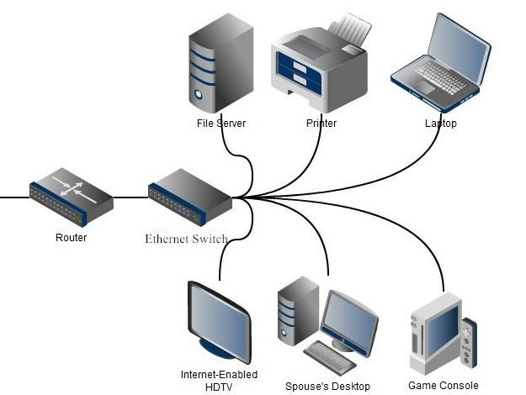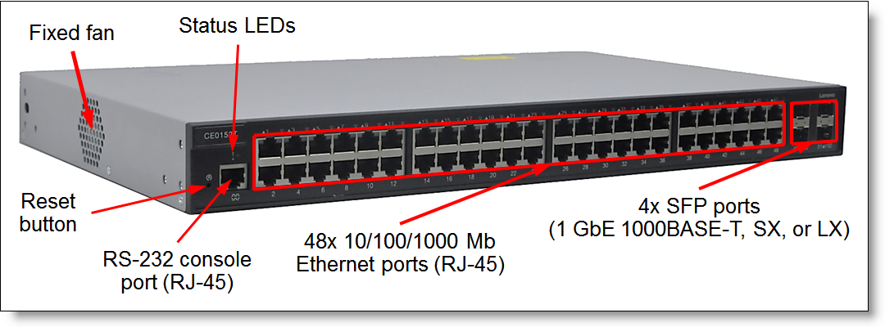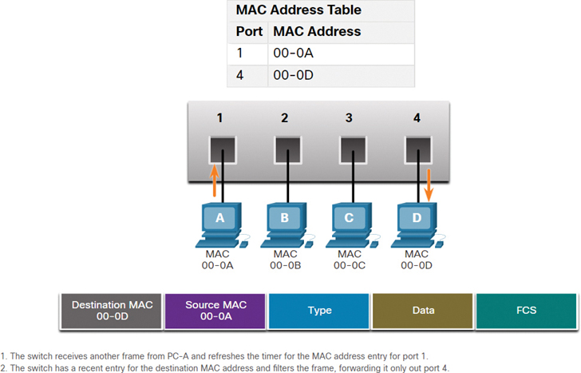
- Explain Switch Boot Sequence
Answer : When a Cisco switch is powered on, it follows a specific process called the boot sequence to start the operating system and load the configuration.
Step 1: POST (Power-On Self-Test)
- The switch performs hardware checks.
- It tests CPU, RAM, Flash memory, and interfaces.
- If a serious hardware error is found, the boot process stops.
Step 2: Load the Boot Loader
- The boot loader program is stored in ROM.
- It initializes the CPU and prepares the file system.
- It locates the Cisco IOS image in Flash memory.
Step 3: Load Cisco IOS
- The IOS (Internetwork Operating System) is loaded from Flash memory into RAM.
- IOS is the operating system that controls the switch.
If no IOS is found, the switch enters ROMMON mode.
Step 4: Load Startup Configuration
- The switch looks for the startup-config file in NVRAM.
- If found → it loads it into RAM as the running-config.
- If not found → the switch enters initial setup mode.
Boot Sequence Summary
Power On → POST → Boot Loader → Load IOS → Load Startup Configuration
Memory Locations Involved
Memory Type | Purpose
ROM | Stores boot loader
Flash | Stores IOS image
RAM | Running IOS & running-config
NVRAM | Stores startup-config
- Explain Three Methods to access Switch Command Line Interface
Answer : A Cisco switch can be accessed and configured through its Command Line Interface (CLI) in three main ways:
Console Access (Local Access)
Define
Direct physical connection to the switch using a console cable.
How It Works:
- Connect a console cable from your PC to the switch console port.
- Use terminal software (PuTTY, Tera Term, SecureCRT).
- No IP address is required.
When Used:
- Initial configuration
- Password recovery
- Troubleshooting when network is down
Features:
- Most secure method
- Requires physical access
- Used during first-time setup
Telnet (Remote Access – Insecure)
Define
Remote access over the network using IP address.
Requirements:
- Switch must have an IP address configured.
- VTY lines must be configured with password.
Characteristics:
- Sends data in plain text
- Not secure
- Older method
Example Command:
telnet 192.168.1.10

SSH (Secure Remote Access)
Define
Encrypted remote access to the switch.
Requirements:
- Hostname configured
- Domain name configured
- RSA keys generated
- VTY lines configured
It Is Better:
- Encrypts username and password
- Secure communication
- Recommended over Telnet
Example Command:
ssh -l admin 192.168.1.10

Summary Table
Method | Access Type | Secure? | Requires IP?
Console | Local | Yes | No
Telnet | Remote | No | Yes
SSH | Remote | Yes | Yes
In Simple Words:
- Console → Direct cable connection.
- Telnet → Remote but not secure.
- SSH → Remote and secure (recommended).

- Explain and Configuring the Cisco Internet Operating System
Answer : Cisco IOS (Internetwork Operating System) is the software that runs on Cisco routers and switches.
It controls the device hardware and provides features such as:
- Routing and switching
- Security
- VLAN management
- Interface configuration
- Network services
It allows administrators to configure and manage devices using the Command Line Interface (CLI).
Cisco IOS CLI Modes
Cisco IOS has different configuration modes:
Mode | Prompt | Purpose
User EXEC | Switch> | Basic monitoring commands
Privileged EXEC | Switch# | Advanced commands
Global Configuration | Switch(config)# | Device-wide settings
Interface Configuration | Switch(config-if)# | Configure interfaces
Line Configuration | Switch(config-line)# | Configure console/VTY

1 Enter Privileged Mode
Switch> enable
Switch#

2️ Enter Global Configuration Mode
Switch# configure terminal
Switch(config)#

3️ Set Hostname
Switch(config)# hostname SW1

4️ Configure Enable Password
SW1(config)# enable secret cisco123

5️ Configure Console Password
SW1(config)# line console 0
SW1(config-line)# password class
SW1(config-line)# login
SW1(config-line)# exit

6️ Configure VTY (Telnet/SSH) Password
SW1(config)# line vty 0 4
SW1(config-line)# password cisco
SW1(config-line)# login
SW1(config-line)# exit

7️ Configure Management IP Address
SW1(config)# interface vlan 1
SW1(config-if)# ip address 192.168.1.10 255.255.255.0
SW1(config-if)# no shutdown
SW1(config-if)# exit

8️ Save Configuration
SW1# copy running-config startup-config

Important IOS Commands
Command | Purpose
show running-config | View current configuration
show ip interface brief | View interface status
show version | View IOS version
copy running-config startup-config | Save configuration

Memory used by IOS
Memory | Purpose
ROM | Stores boot loader
Flash | Stores IOS image
RAM | Running IOS & running-config
NVRAM | Stores startup-config

In Simple Words
Cisco IOS is the operating system of Cisco devices.
To configure it, you enter different modes, apply settings like hostname and passwords, configure interfaces, and then save the configuration.

- Explain Switch Port
Answer : A switch port is a physical interface on a network switch used to connect devices such as computers, printers, servers, or other switches.
Example port names:
- FastEthernet0/1
- GigabitEthernet0/1
Each port acts as a separate connection point in the network.
Functions of a Switch Port
- Connects end devices to the network
- Sends and receives Ethernet frames
- Learns MAC addresses
- Can be assigned to VLANs
Each switch port is its own collision domain, which improves network performance.
Types of Switch Ports
1️ Access Port
- Belongs to only one VLAN
- Used for PCs, printers, and end devices
- Does not tag frames
Example Configuration:
Switch(config)# interface fa0/1
Switch(config-if)# switchport mode access
Switch(config-if)# switchport access vlan 10

2️ Trunk Port
- Carries multiple VLANs
- Used between switches or switch-to-router connections
- Uses VLAN tagging (802.1Q)
Example Configuration:
Switch(config)# interface fa0/24
Switch(config-if)# switchport mode trunk

Common Port Commands
Command | Purpose
shutdown | Disable the port
no shutdown | Enable the port
description | Add description to port
speed | Set port speed
duplex | Set duplex mode
Example:
Switch(config-if)# description Connected to HR-PC
Switch(config-if)# no shutdown

In Simple Words
A switch port is the physical connection point on a switch that connects devices to the network. It can work as an access port (one VLAN) or a trunk port (multiple VLANs).
